**EVIDENCES FOR LAB 2.5**

Home Screen: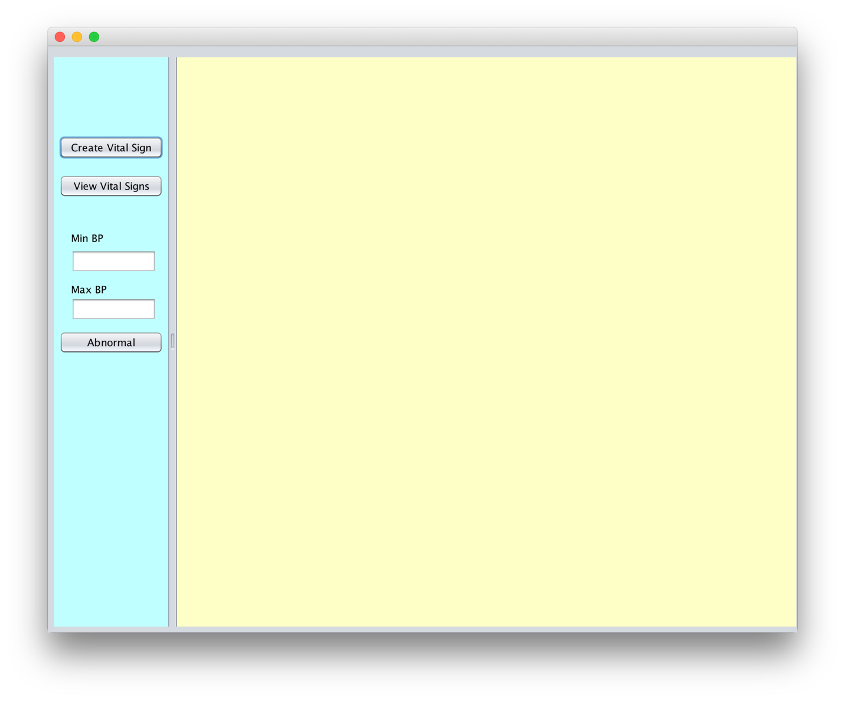

Creating a Vital Sign: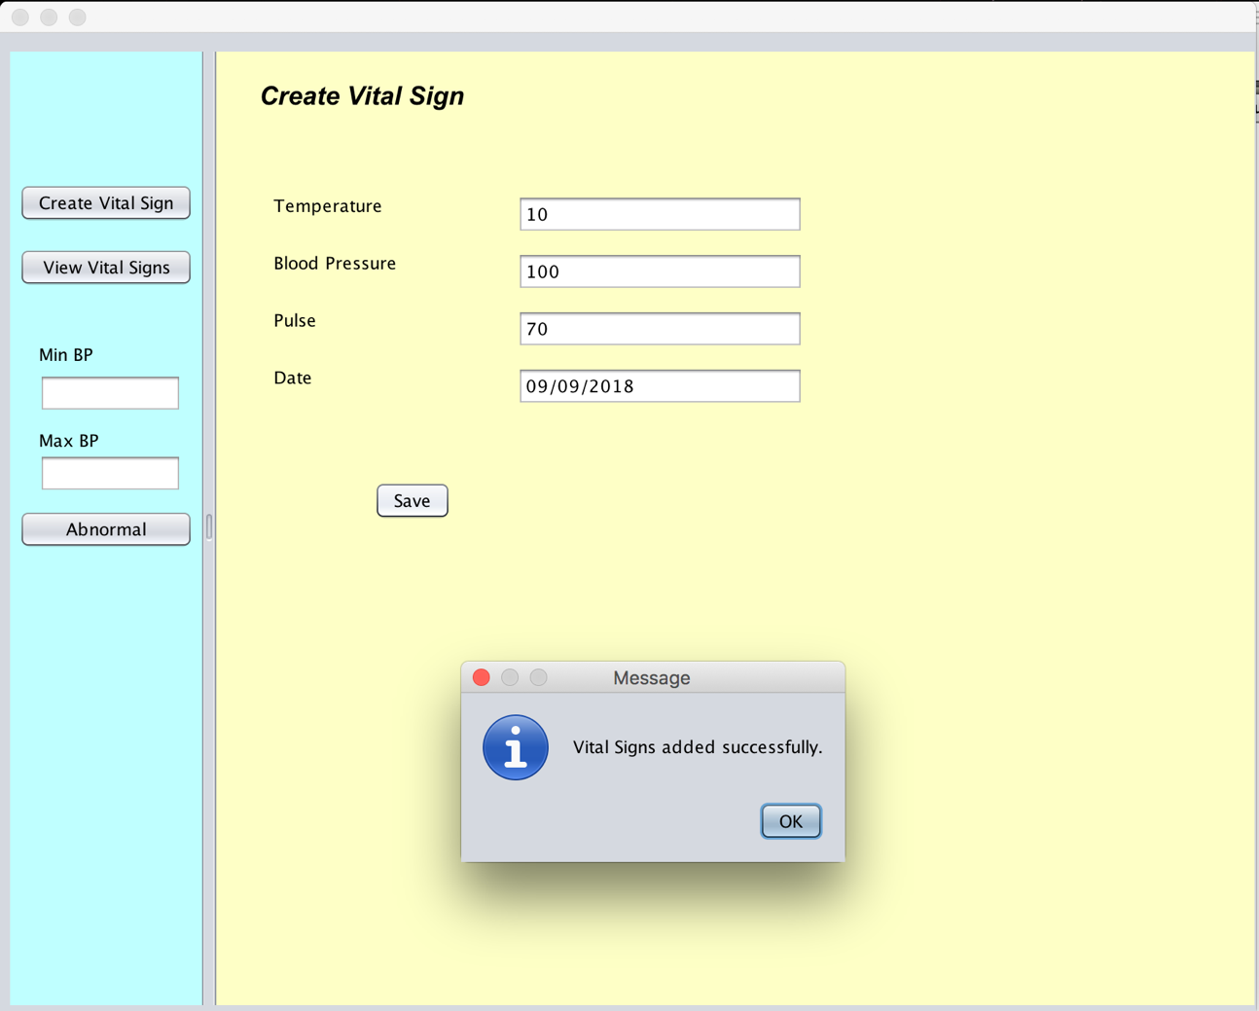

View Vital Signs :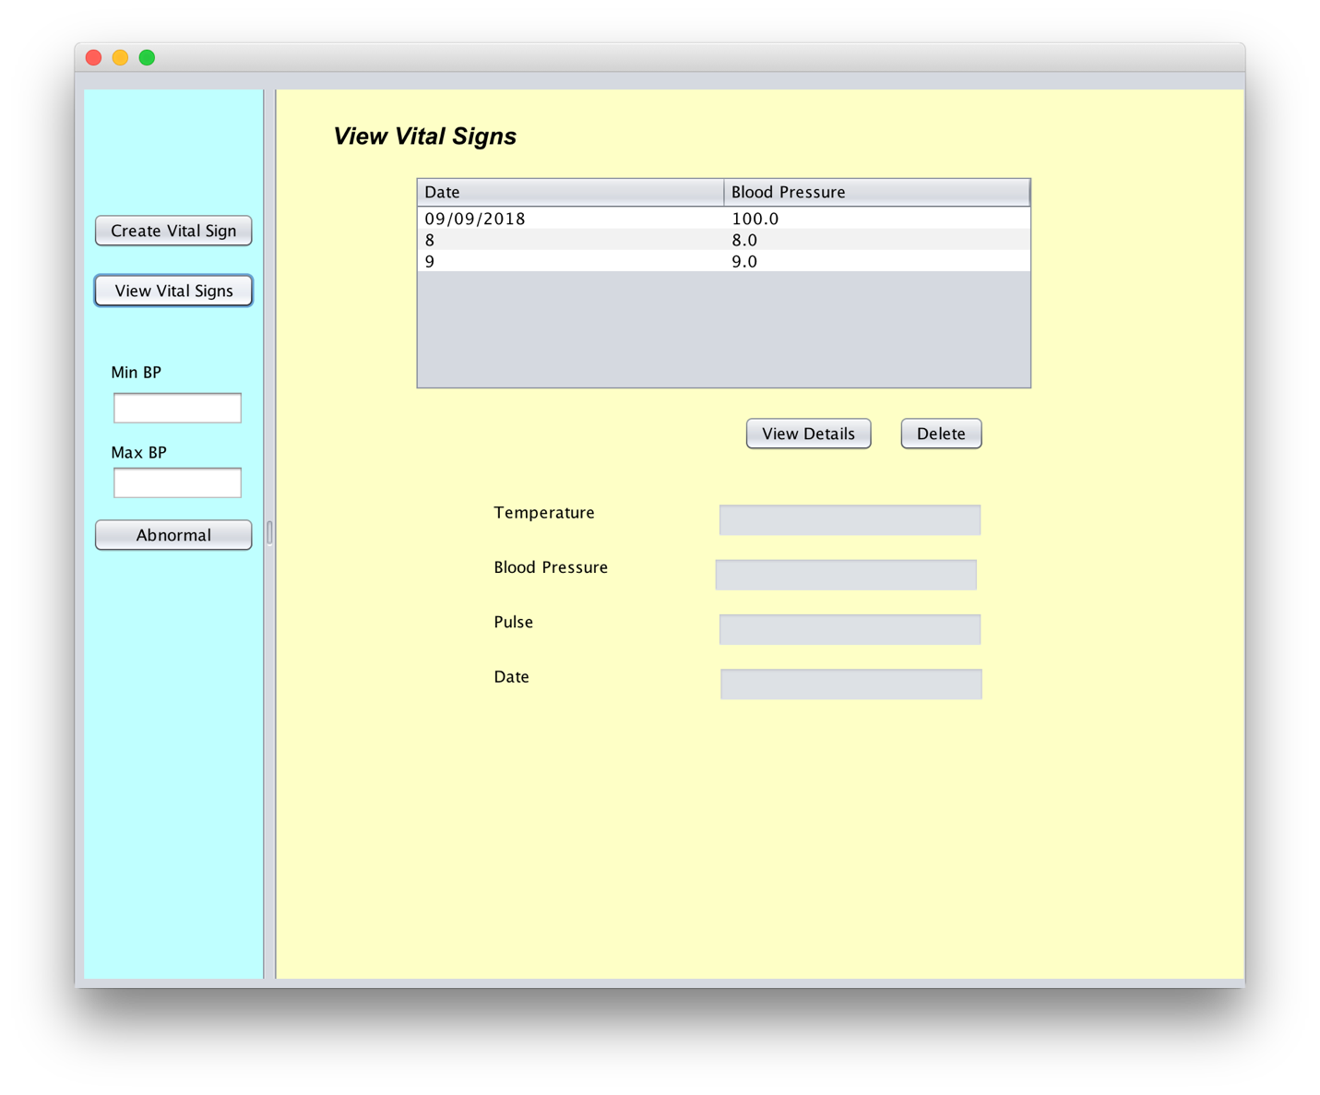

View details of selected Vital Sign:

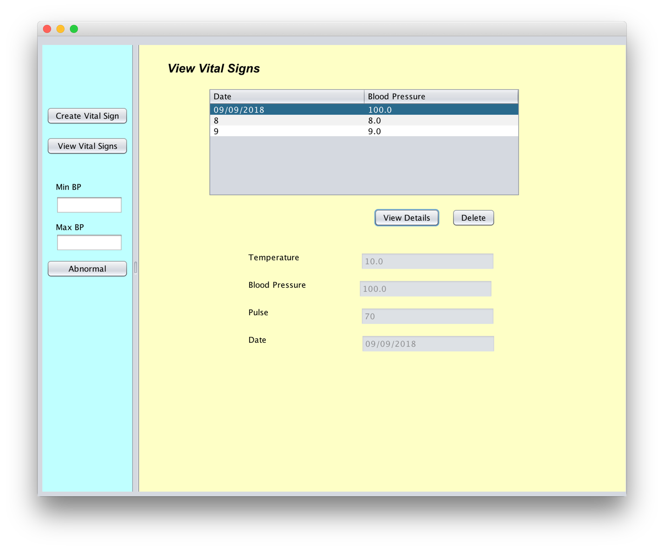

Deleting a Vital Sign: User is asked for confirmation before deleting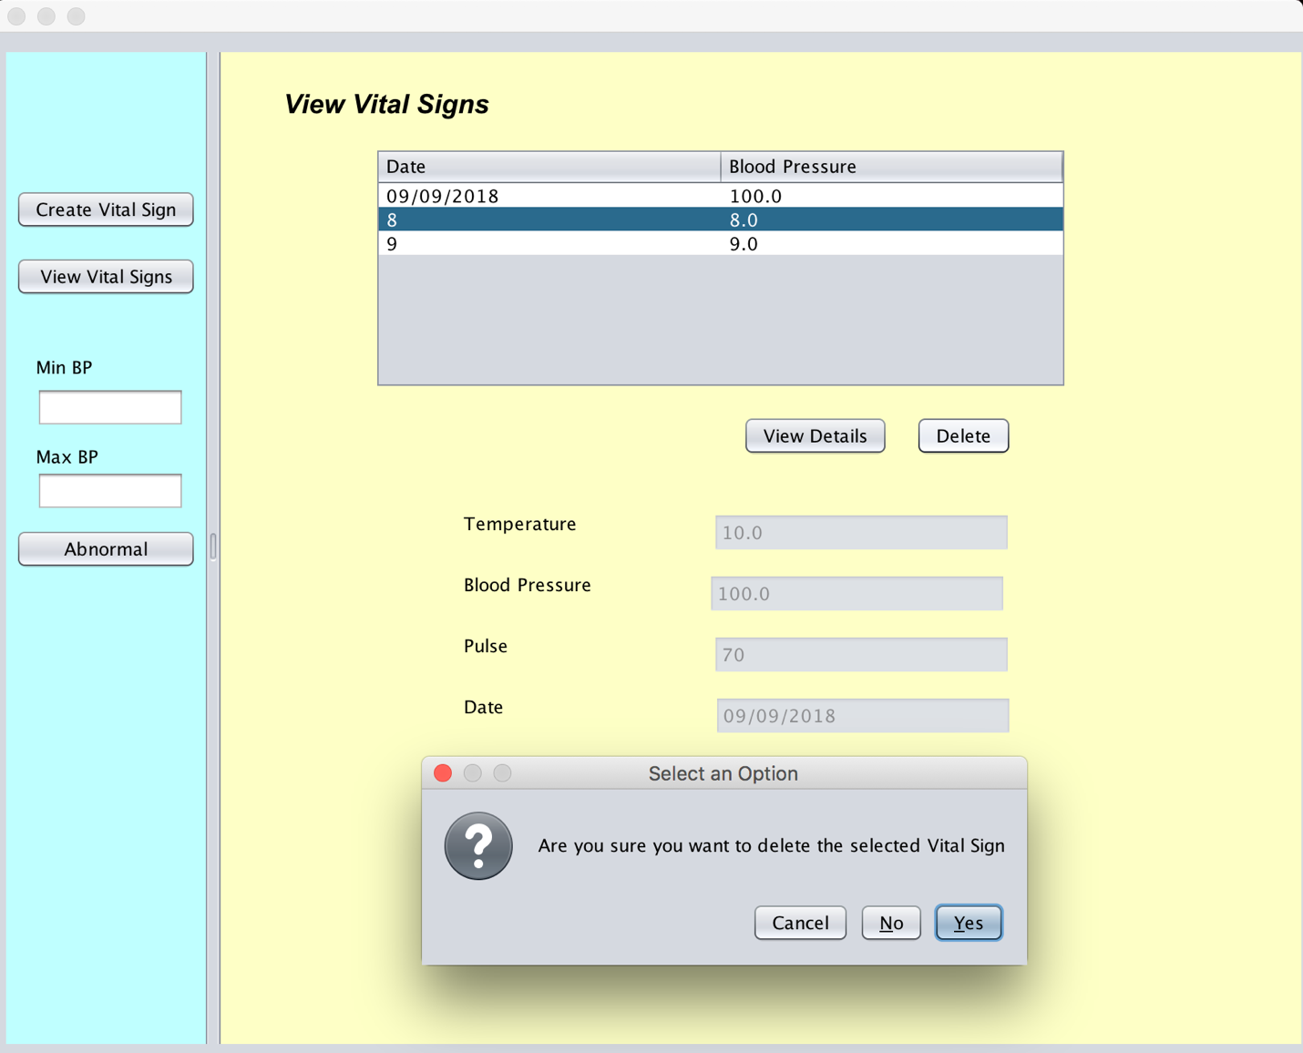

Vital Sign deleted success message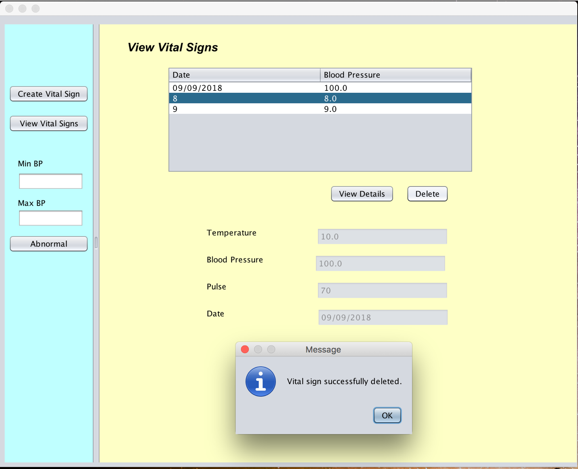

Vital Sign Deleted Successfully:

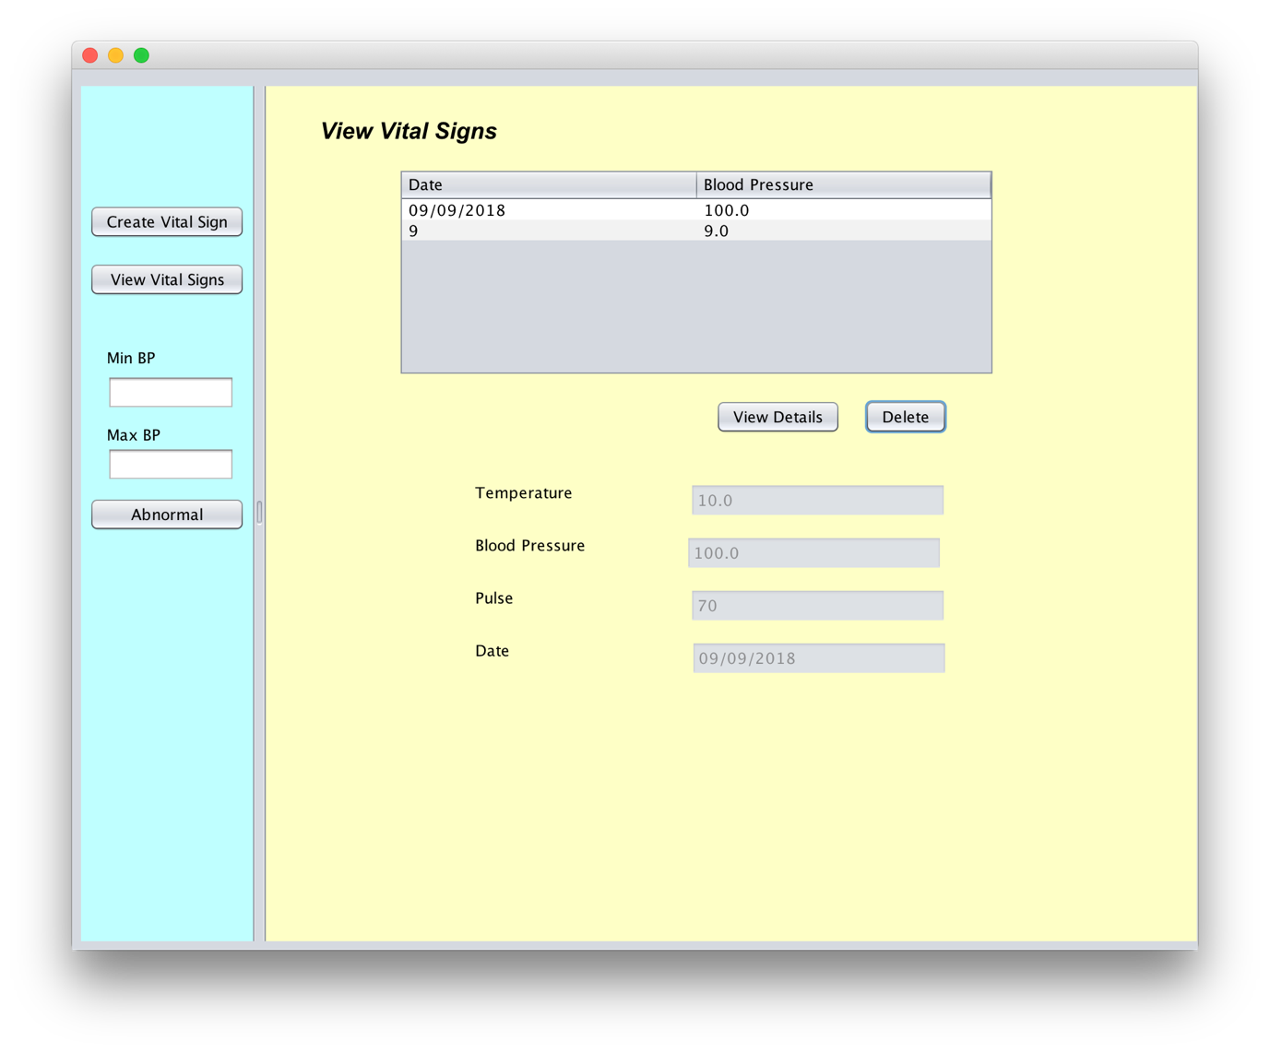

Abnormal Vital Sign Screen with all Vital signs which fall outside the BP range selected on the left pane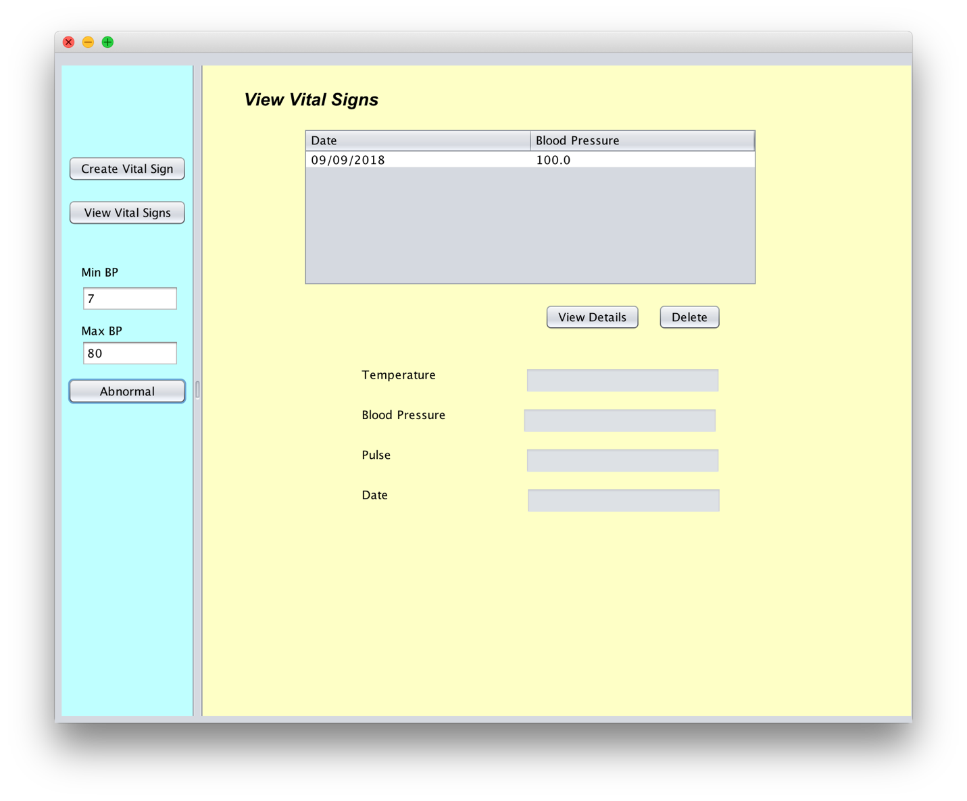

Showing details of the selected Abnormal Vital Sign

